Promise was that “on the next page,” which is this one, you’d show entire project, so that’s the first project you need to show.
(show finished circuit)
The circuit is done. Now we need to program it.
For me, the programming didn’t come easy. In fact, writing that first program for the Arduino wasn’t one of those movie montages where the hacker hero types fast and yells, ‘I’m in!’ It was three hours that evening of trial, error, and me wondering why my LED refused to blink.
Here’s the code I wrote.
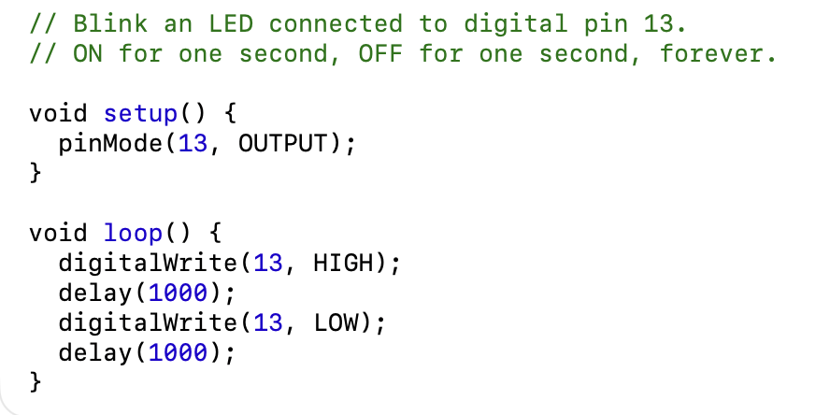
I wish I could tell you I wrote that code from scratch and am well on my way to being a master programmer who makes microcontrollers kneel before my will.
Except I copied that code, line by line, from Sparky McVoltage, author of Simple Robots for Clever Humans.
He put that code in Chapter 3 of his book. In the chapter, he also explained, step by step, how to hook up the Arduino to the computer, how to download the coding software, how to upload the code…
It turned out he even had a web site with videos on how all this works. His videos are funny. Whoever he is (he never seems to show his face), he teaches Arduino like he’s narrating a heist move.
Are you building along with me as you read? You should be. If you want to build this circuit, make it work, and understand all the code, I need you to now go to Sparky McVoltage’s web page:
www.sparkymcvoltage.com
Find the lesson called “Chapter 3: Your First Arduino Build.”
You can follow the QR code in the margin to go straight to the web site. Don’t worry, I’ll still explain the important parts here. In fact, let’s go through that whole program.
Here’s the first part of the code:
// Blink an LED connected to digital pin 13.
// ON for one second, OFF for one second, forever.
These are called comments. In C++, when you type two backslashes like this:
//
you’re telling the computer, “The rest of this line is a note for me and anyone else reading the code,” and that’s what those lines are. We say
// Blink an LED connected to digital pin 13
as a kind of title to the code so anyone reading knows what this program is, and we say:
// ON for one second, OFF for one second, forever.
to explain exactly what this program does.
Then we get into the actual code.
void setup() {
pinMode(13, OUTPUT);
}
That block you just read tells the Arduino to setup Pin 13 as an Output pin, meaning any wire pluged into Pin 13 is going to have an electrical signal come from the Arduino and out through the wire to whatever’s connected.
Now we’re into the heart of it.
void loop() {
digitalWrite(13, HIGH);
delay(1000);
digitalWrite(13, LOW);
delay(1000);
}

That is the program. It’s a loop because it runs over and over again.
digitalWrite is called a function, and first it tells Pin 13 to turn on, or send a HIGH electrical signal. Then the delay function has the program wait for 1000 milliseconds before moving to the next line. Then digitalWrite again, only now Pin 13 is turning off, or having a LOW electrical signal. Another 1000 milliseconds of delay finishes the loop, and then the loop starts again, over and over, for as long as the Arduino stays powered on.
In other words, this program turns an electrical current, outputting from Pin 13, on and off again, with 1000 milliseconds (or 1 second) in between each blink.
And voila! You have a blinking LED!
(sketch of blinking LED on breadboard)
When it finally worked, I just sat there for a minute, getting hypnotized by the blinking light. After all those trial runs and wrong wires and mystery errors, it was alive. Just a pulse of light, steady and patient, like a heartbeat from the circuit itself.
But Marvin didn’t just want us to make one blinking LED. He wanted us to build The Beacon of Orinthgloth, which had three LEDs, one blue, one red, one yellow.
I was pretty sure I knew how to do that now. Seems easy, right? Just add more LEDs to the breadboard and write more code to make them blink.
Except Marvin wanted them to blink in The Sequence of Rumradikan.
And he never told us what that even meant.
That night I kept thinking about it. What is The Sequence of Rumradikan? I wondered if there was another clue somewhere we were meant to find. I wondered

, I kept thinking about it. Then school happened. Homework, basketball, WOMP auditions coming up. And slowly, without really deciding to, I stopped thinking about the beacon. So did my friends. Or so I thought.

But he wanted us to make them blink in The Sequence of Rumradikan, and he never told us what that even meant.

